**Essential Dignities**

[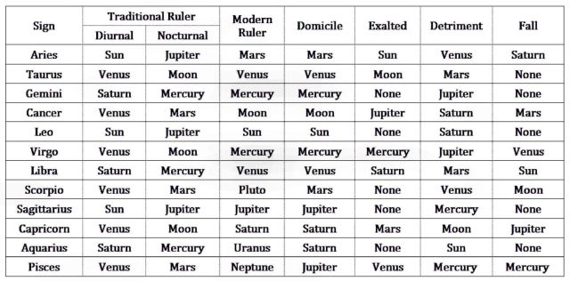](https://benebellwen.com/wp-content/uploads/2022/10/essential-dignities-by-sign.jpg)*Essential Dignities by Zodiac Sign*

In astrology, the qualitative state of the celestial bodies are affected by which zodiac sign they’re positioned under. The 17th century astrologer William Lilly described these qualitative states as essential dignities, either strengthening the innate qualities of the planet or debilitating and weakening the innate qualities of the planet.

[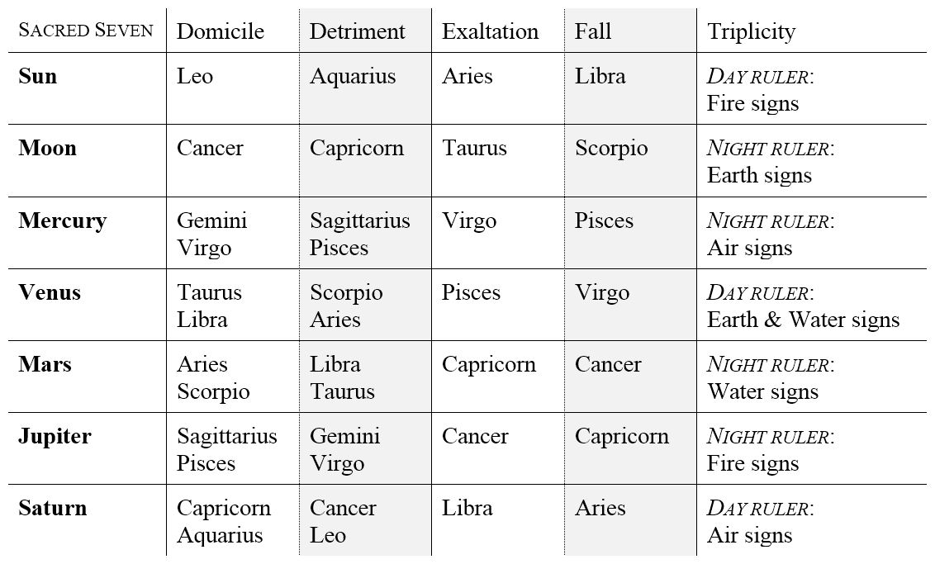](https://benebellwen.com/wp-content/uploads/2024/09/planetary-dignities-and-debilities-traditional-astrology.jpg)

**Dignities** are conditions of placements in a chart where the planet’s influence is strengthened, referred to as **Essential** Dignities. Planets in Domicile or in Exaltation are the planet’s Essential Dignities. In Domicile, the planet is in the sign of its ruler, or its Domal Dignity, such as the Sun in Leo, or Jupiter in Pisces. When the planet is in Exaltation, as the Sun is in Aries, or Mars is in Capricorn, the influences corresponding with that planet are augmented in the native’s life path, though not quite as favorable as when the planet is in its Domal Dignity.

**Debilities** are conditions of placements in a chart where the planet’s influence is weakened, referred to as **Accidental** Dignities, such as planets in Detriment and planets in Fall. A planet in the opposite zodiac sign of the one it rules is said to be in Detriment. For example, the Moon rules Cancer, so when it is in the opposite sign Capricorn, the Moon is in Detriment. Venus rules over Libra, so when it is in Scorpio, the sign opposite to Libra, the planet is in Detriment. This is the weakest placement for a planet to be in. When the planet is in the opposite sign from the one it is in Exaltation, it is said to be in its Fall. Mercury is exalted in Virgo, the opposite sign to Virgo is Pisces, so Mercury is in its Fall under Pisces. While not as malefic of an influence as if the planet were to be in Detriment, a planet in its Fall nonetheless weakens the productive attributes of the planet’s associations, and also, generally weakens the planet’s role in the native’s life path.

A third Debility and fifth of the classes of Dignities is when a planet is Peregrine, or “alien.” A planet Peregrine when it possesses no essential dignities at all, is neither dignified or debilitated, *and*has no angular aspects associating it with other planets in the chart.

The planetary ruler of a **Triplicity** is more commonly observed in mundane or horary astrology, and less so in natal astrology, which is the subject matter of this handbook. Nonetheless, it may be helpful to note how triplicities might guide which placements in the native’s chart you emphasize your interpretation on.

A planet in its Triplicity is considered high in ranking, which will in turn elevate the ranking of the native with respect to the area of life the placement is impacting.

[](https://benebellwen.com/wp-content/uploads/2024/09/planetary-dignities-and-debilities-traditional-astrology.jpg)

For example, if the native is born during an evening hour (i.e., Sun below the horizon) and thus is said to have a nocturnal chart, and her natal Jupiter is in one of the Fire signs (Aries, Leo, or Sagittarius), then Jupiter in its Triplicity will affect the native more than one whose natal Jupiter is *not*a Fire sign. A Jupiter Fire sign could mean that the force and implications of Jupiter Returns are stronger for this native.

Whereas if the native is born during a daylight hour (i.e., Sun above the horizon) and thus has a diurnal chart, with Saturn in one of the Air signs (Gemini, Libra, or Aquarius), then Saturn is in its Triplicity, blessing him with the productive qualities of Saturn (serious, organized, disciplined, determined, high-achieving, prudent, and more likely to succeed in a conventional corporate track).

[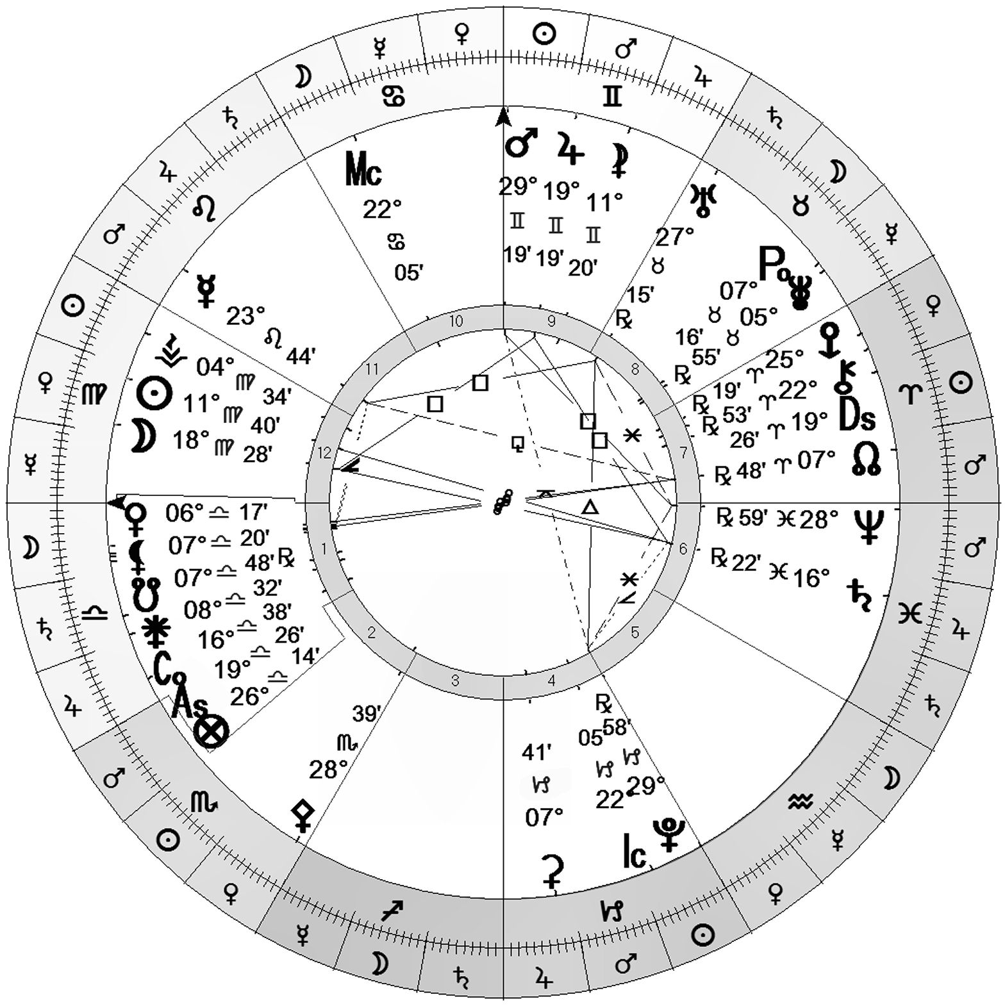](https://benebellwen.com/wp-content/uploads/2024/09/chart_image.jpg)

In the sample natal chart above, Venus is in Libra, so it’s in Domicile, or its Domal Dignity. Jupiter is in Gemini, where the planet is in Detriment. For this native, the impact Venus has on their life trajectory will be greater than the impact of Jupiter. The positive attributes of Venus in Libra will also be more prominent in this native.

With your birth chart in hand and referencing the Dignities chart as a checklist, go through the Sacred Seven one by one to see which of these planets in your chart are in Domicile, Detriment, Exaltation, Fall, or in its Triplicity.

In an **electional astrology** where you are picking an auspicious date for a wedding, you’ll want to avoid any date and time where Venus is in Detriment or in Fall, and most preferably when Venus is it the house of its Domicile or when it’s in Exaltation.

In a [**past life astrology reading**](https://wp.me/P32or0-1oV), the Essential Dignities can denote the karmic blessings you’ve earned as a result of past merits earned, whereas the Debilities or Accidental Dignities denote ways you may have hurt others in a past life, wrong turns you may have made, and now this lifetime there’s a reckoning for it. One explanation for my Venus in Detriment at birth would be that perhaps I was a heartbreaker in a past life, and now so in this life, it’s my turn to know what that feels like.

By going down the list of Sacred Seven in your chart to document which of your natal planets are in Dignities or Debilities, you will have a better idea of which of these planets have more influence over you, and whether that influence leans toward fruition or toward challenge. Fruitions show you karmic merits earned, and challenges show you what past decisions you’re now paying for.